Carburetion

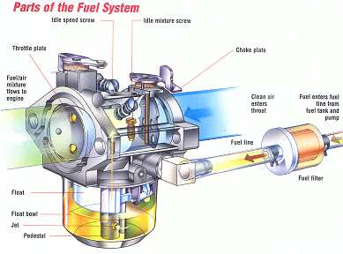

Unit Handouts

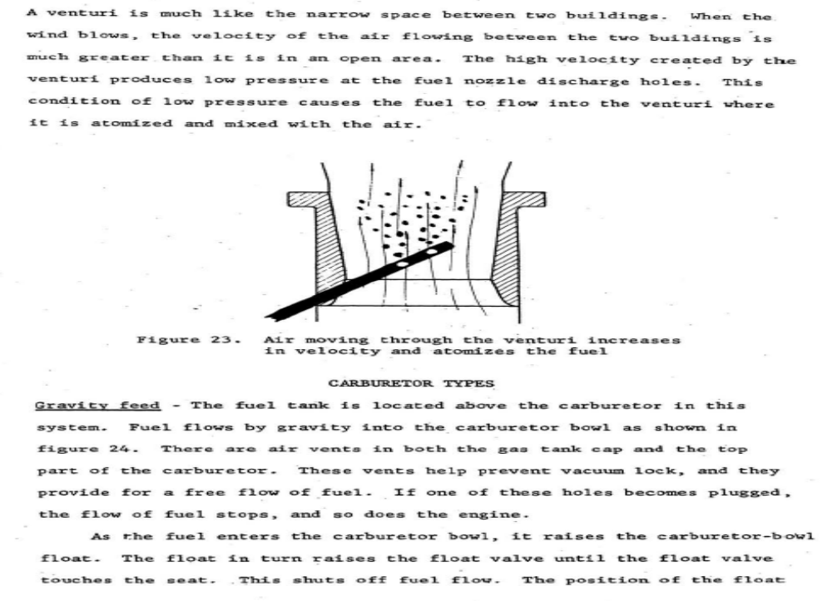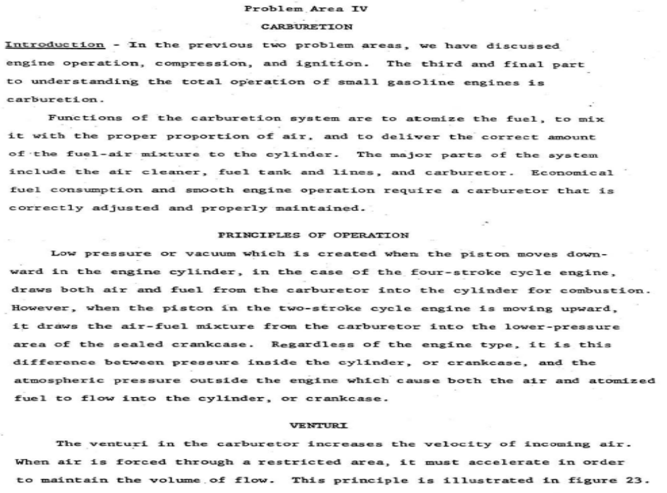

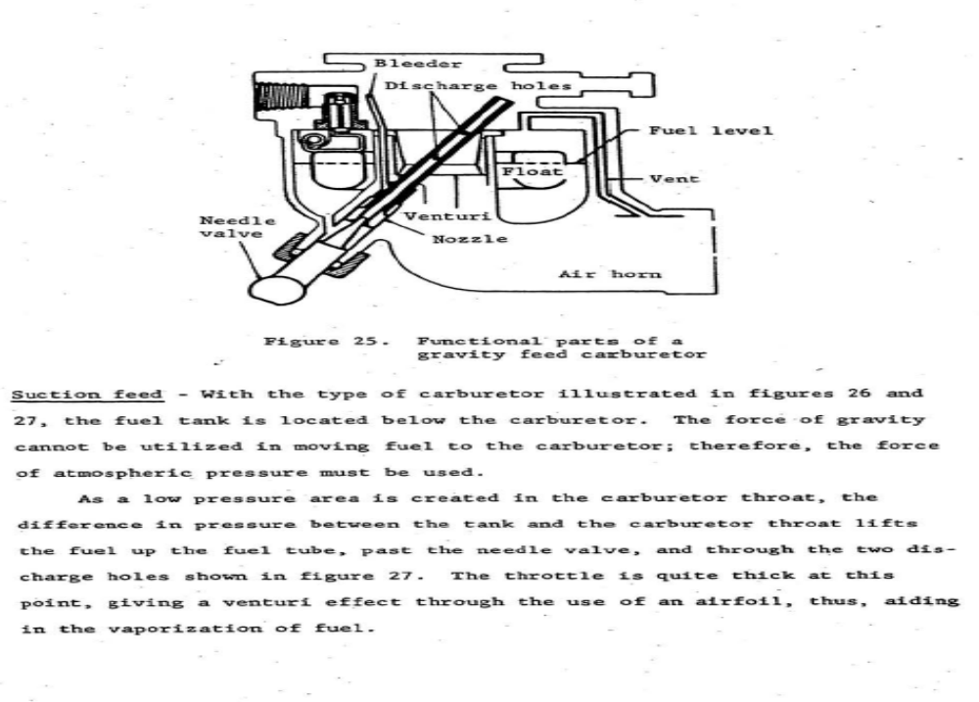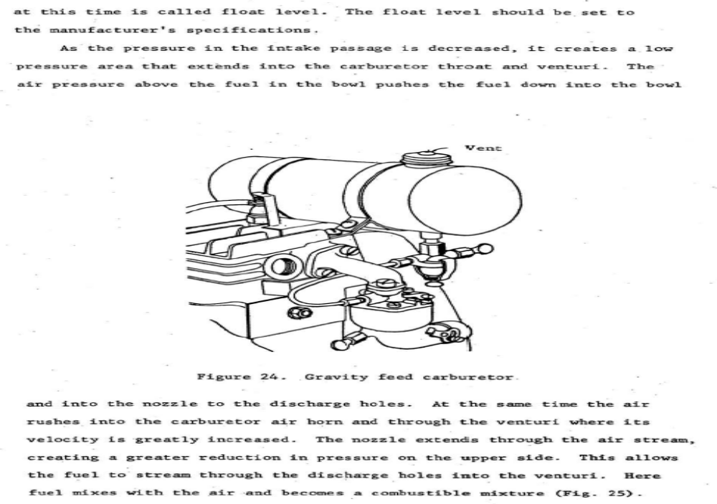

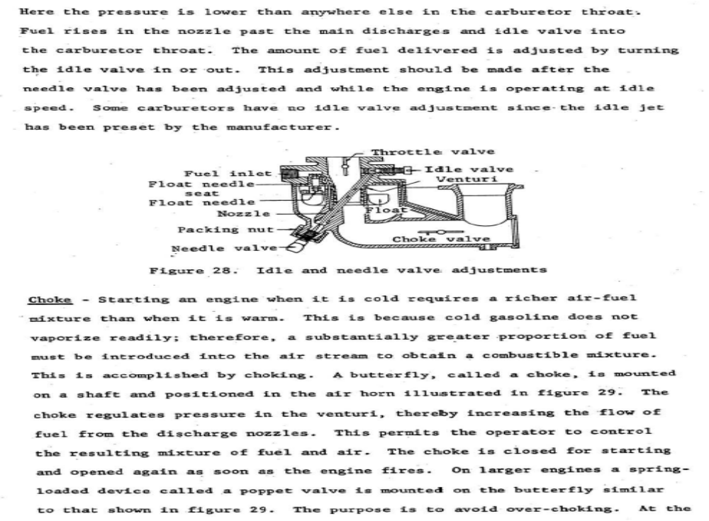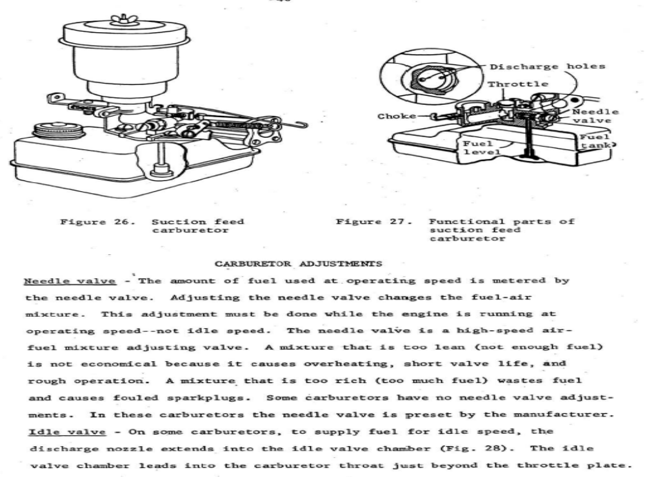

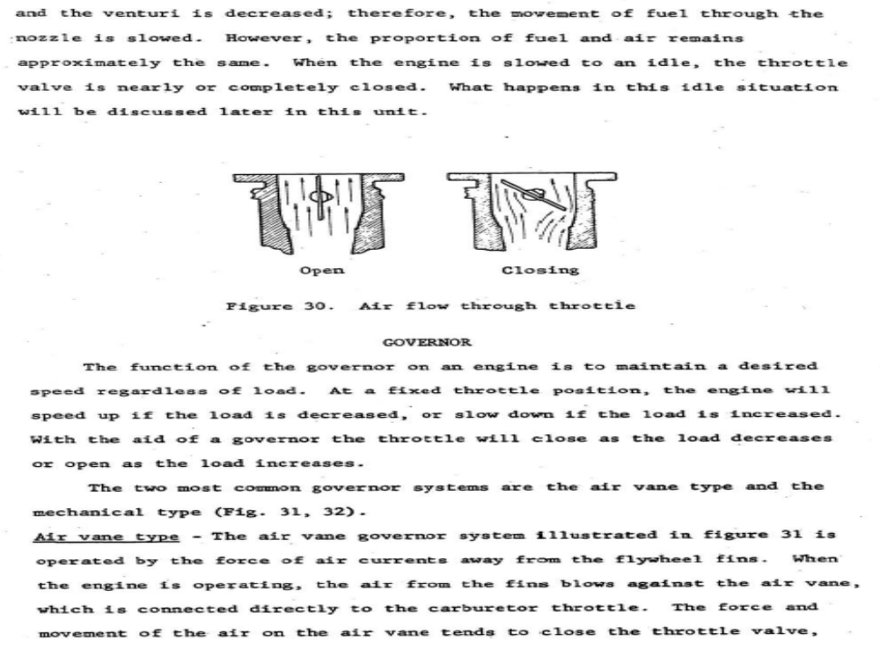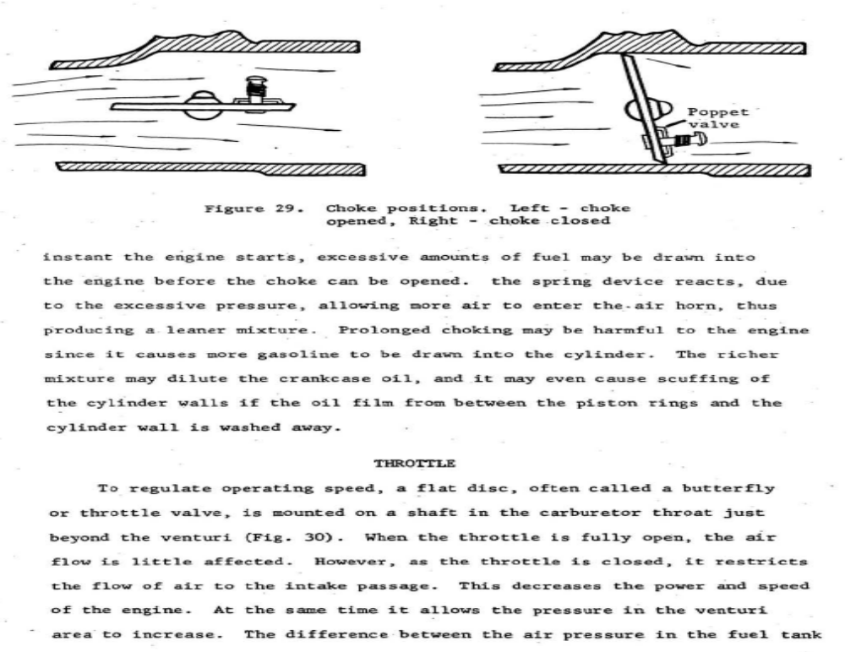

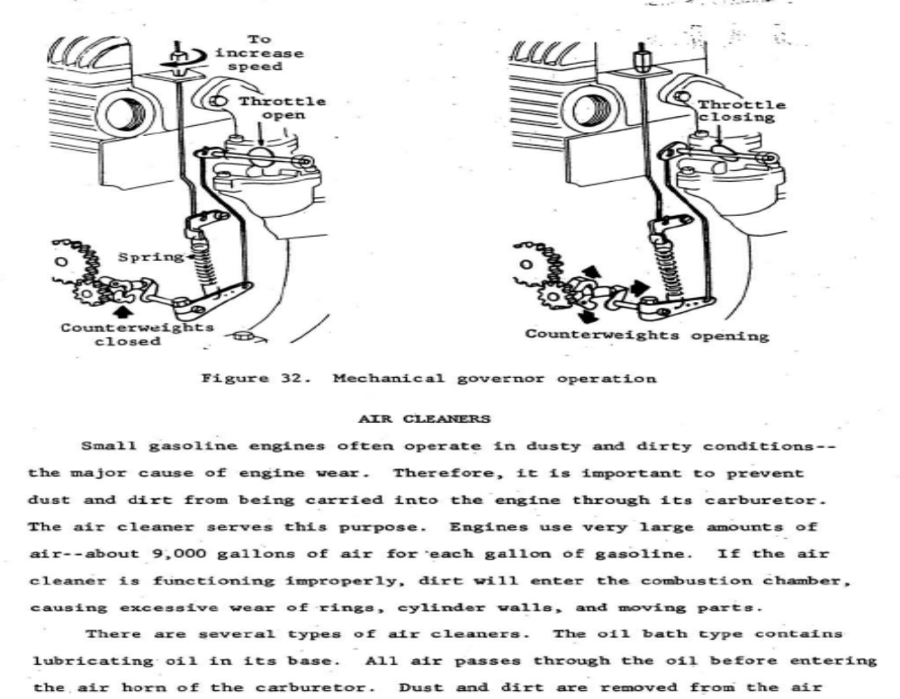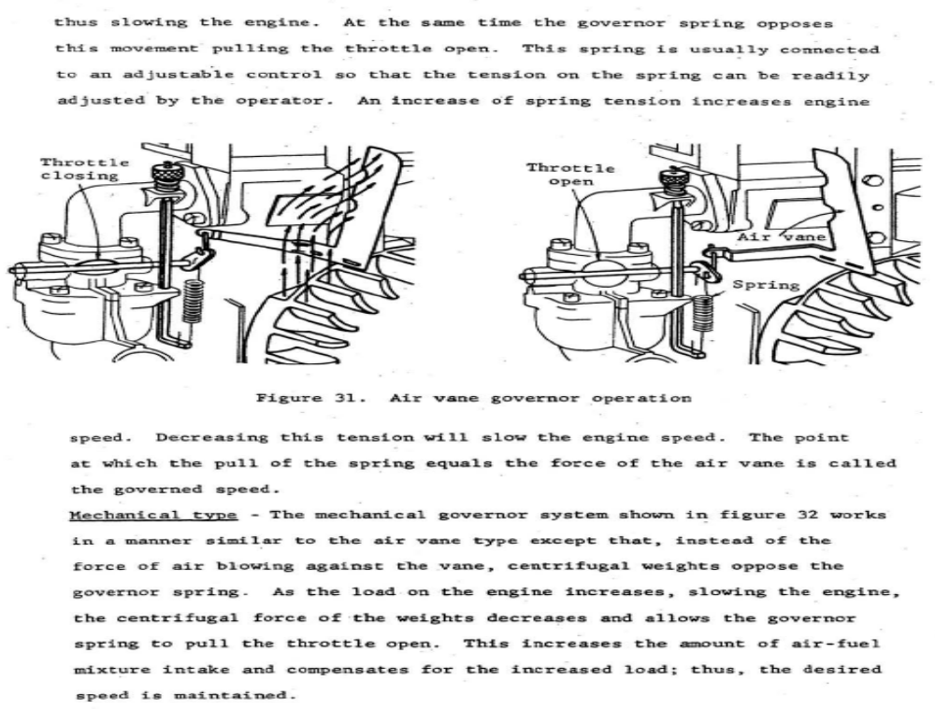

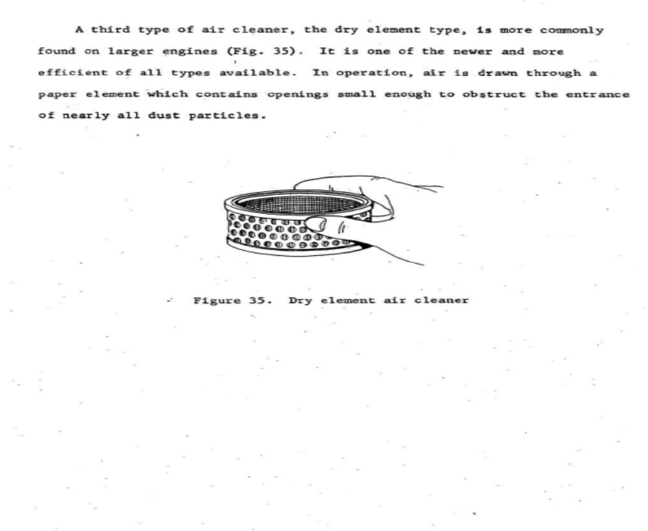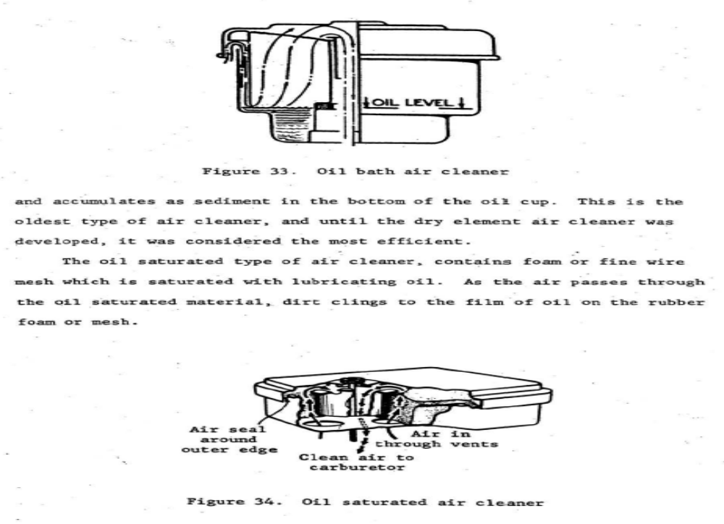

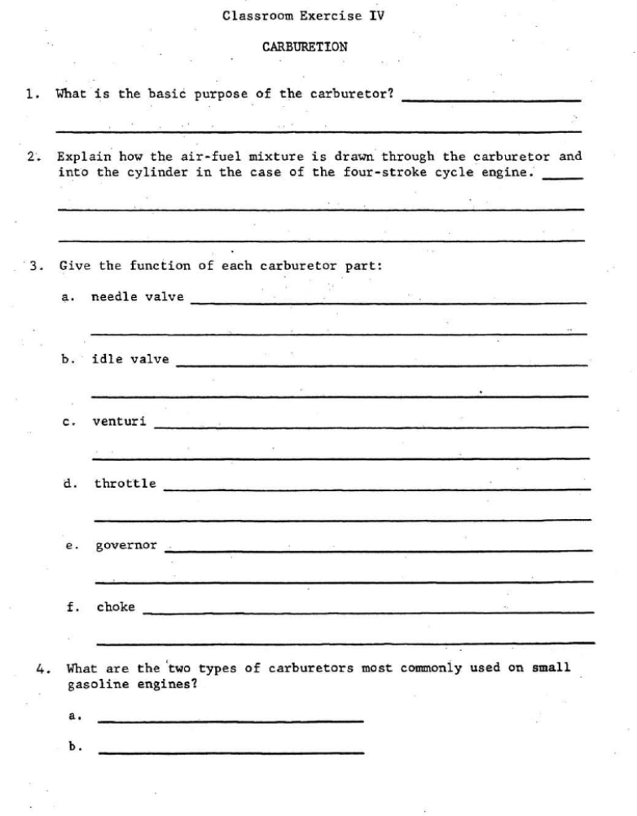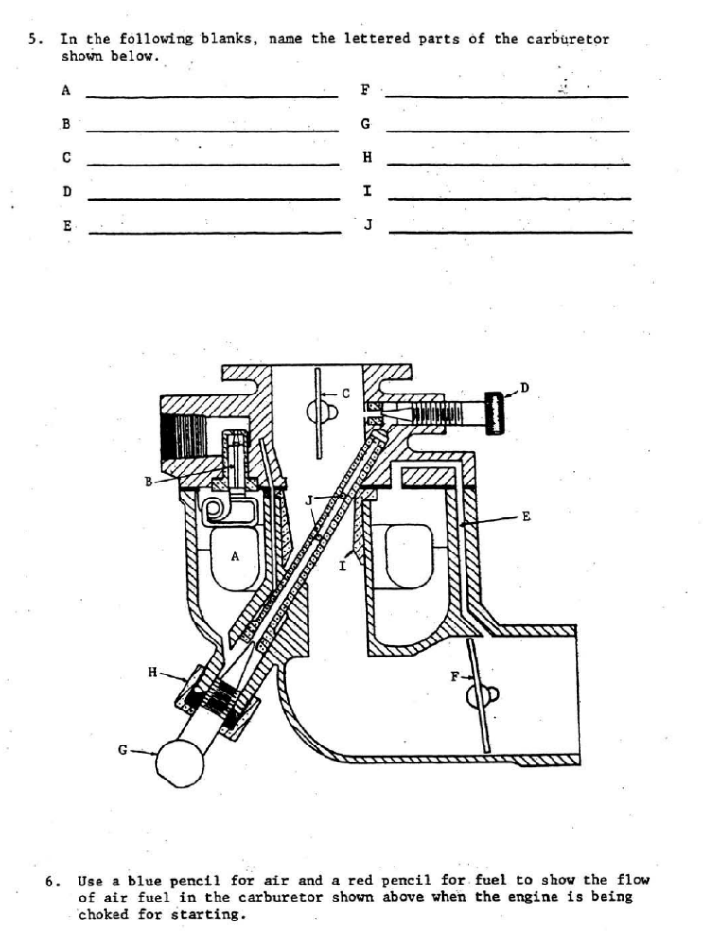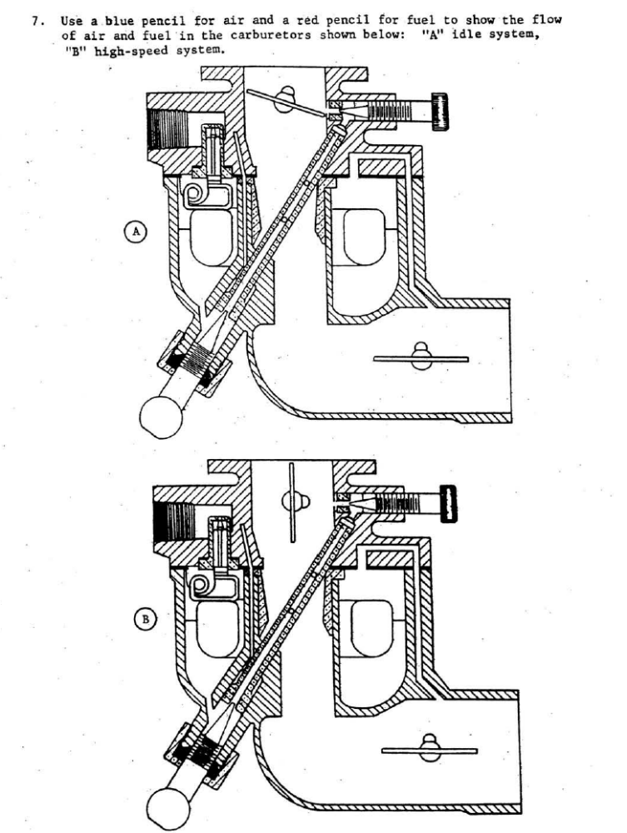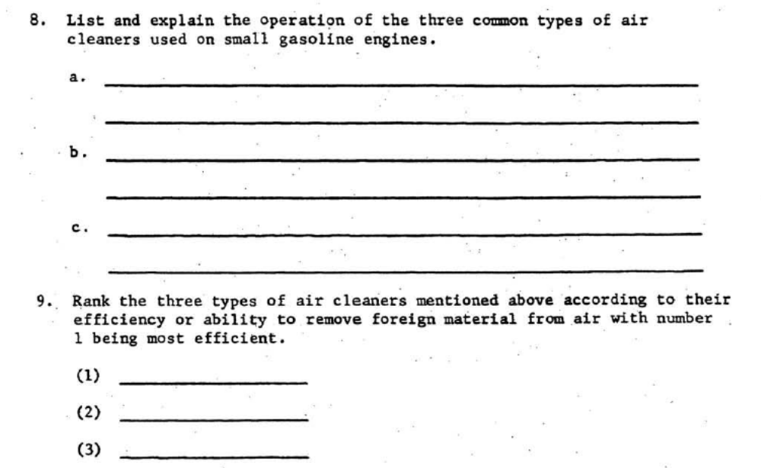

Name: __________________________________ Date: ___________________ Period: _________

Carburetion
F J T J U U O C N O R Q A S T C U T Z I H N V I B A C G E E
N Z N X D K Q S H E F O G Q X F I Q Z V A S H M C C A O Y Q
Q K E Z R F I O M O E P G Q R U L D V T R R R C U C R V P A
O P M Y A U C I R S K W I A C V Z M U B O H E H V M B E X B
D H T U F R R R V Z Z E N R G C S R Y B T L R K C C U R E F
A R S V T P H S W J I V I I S D A F C Y E G E M F L R N Y I
L S U J C S O L A K X C T T K L L I R R R B D S Q X E O I D
J A J Q A E O I R B G N A E D G F O A P U M B Z V L O R M D
J W D D R M R N G N S B Y R W D T T N I B S W S W X R T H S
H Q A C B N G U I T I C A V Q E I D X X R I M T Z L E H S X
J P D D U W J L S L M F C K R O J P O A A Z U F L Q E R D R
H O A G R X D B I S T B I U N Y I I B W C V J K P L H O K G
T Z O Y E I A T H C E V B W C S E N S I T I V I T Y W T V E
W I L J T F Y I A B Z R E L T T O R H T F L O A T V P T Y P
L R D V O M R R R Y A L P N M T J Q C I A A J M M E D L R T
F W M N R N B E X C L J V C T E L L U V R Z P I N E K E Y W
X U G X D U N D M F L T K P I U Q Z H L D U D X O O T C D A
G A V O R X N G C O T E T J G R R J B F N M T G M F J O R J
S Y X E W V A B N J N N A T N Z E I S Q W K X N G H Z N Q A
K P T A H R U C U O N S E N X W O H P V O L D I E L Q T D Z
K O I S H R E U D B J F W E E I W V P R D W S T O V I R U Y
R G J P E R U T X I M L E U F R I A O S I J W N B H C O G N
F R A E C O N O M I Z E R C I R C U I T O N R U V Q L L I H
G I U C Z L T T L B D F T K J B W J B O X M C H X Q N E U D
D U B L O R G H X A J D F X P V C J V I F T T I X S J O B X
H P S C P F M Y T A O O P O B D Y L V P L T P A P K U M C A
L O R T N O C E L T T O R H T L A U N A M C O O D L K P O P
U R C B I M S M P J B K F N S R X Y C O K L X Q A D E J P F
T I R M U Z S N F H L R E M T J H T O I R J R I T W A Y B P
D A E N S M G D V S J U W Q P H E R X M Q K N K S V P N P R

ACCELERATION WELL
AIR CLEANER
AIR FUEL MIXTURE
ATMOSPHERIC PRESSURE
CARBUREOR
CHOKE
DIAPHRAGM CARBURETOR
DOWNDRAFT CARBURETOR
ECONOMIZER CIRCUIT
FLOAT
GOVERNOR THROTTLE CONTROL
HUNTING
IDLING CIRCUIT
LOAD ADJUSTMENT
MANUAL THROTTLE CONTROL
NATURAL DRAFT CARBURETOR
PRIMER
SENSITIVITY
STABILITY
THROTTLE
UDRAFT CARBURETOR
VENTURI
VENTURI PRINCIPLE

Define the Terms using your own words. Use Chapter 8 in the Small Engines Book to help
ACCELERATION WELL
AIR CLEANER
AIR-FUEL MIXTURE
ATMOSPHERIC PRESSURE
CARBURETOR
CHOKE
DIAPHRAGM CARBURETOR
DOWNDRAFT CARBURETOR
ECONOMIZER CIRCUIT
FLOAT
GOVERNOR THROTTLE CONTROL
HUNTING
IDLING CIRCUIT
LOAD ADJUSTMENT
MANUAL THROTTLE CONTROL
NATURAL DRAFT CARBURETOR
PRIMER
SENSITIVITY
STABILITY
THROTTLE
UDRAFT CARBURETOR
VENTURI
VENTURI PRINCIPLE

Carburetors

- List and explain the principles of carburetion | - Explain float-type carburetor operation
- Identify 3 basic types of carburetors | - Explain the operation of the diaphragm-type carburetors
- Explain how manual throttle controls work | - List the basic functions of a governor
- Explain how air filters function | - Explain the operation of air-van, centrifugal, and vacuum governors
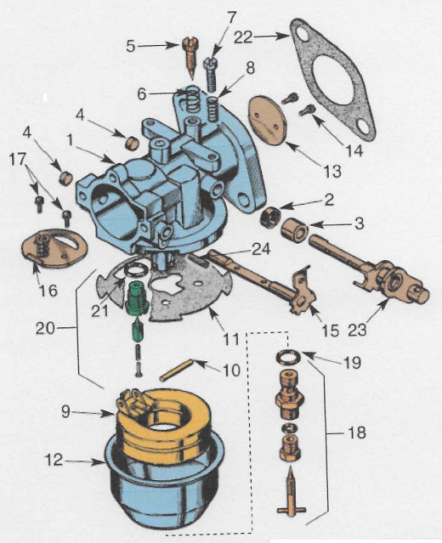

- __________________________________
- __________________________________
- __________________________________
- __________________________________
- __________________________________
- __________________________________
- __________________________________
- __________________________________
- __________________________________
- __________________________________
- __________________________________
- __________________________________
- __________________________________
- __________________________________
- __________________________________
- __________________________________
- __________________________________
- __________________________________
- __________________________________
- __________________________________
- __________________________________
- __________________________________
- __________________________________
- __________________________________

Diagram the different carburetor functions:
Choked | Idle
Part Throttle | Full Throttle

Name: ____________________________________________ Date: ___________________ Period: _________

Carburetion Review

- What is the primary function of the carburetor?

- In order for an engine to operate, what must the carburetor do? How does it accomplish this?

- Explain the venturi principle/effect.

- Identify the basic types of carburetors (Natural draft, Updraft, Downdraft). Explain how each one operates.
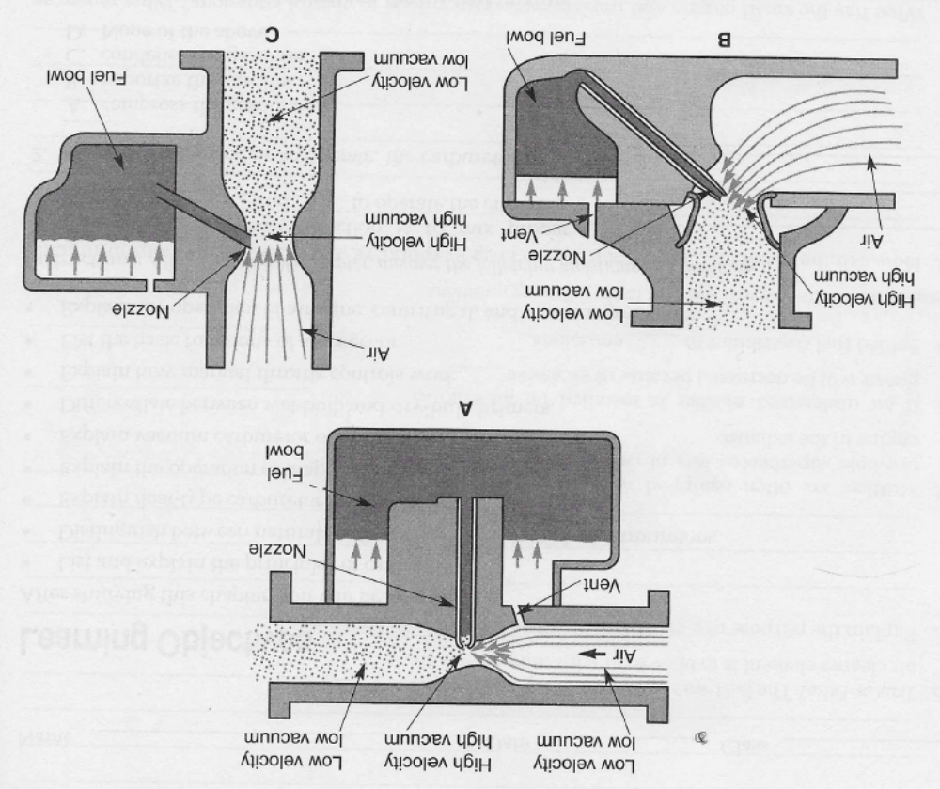
- What is the purpose of the carburetor float? How does it function?

- Explain the main purpose of the throttle valve.

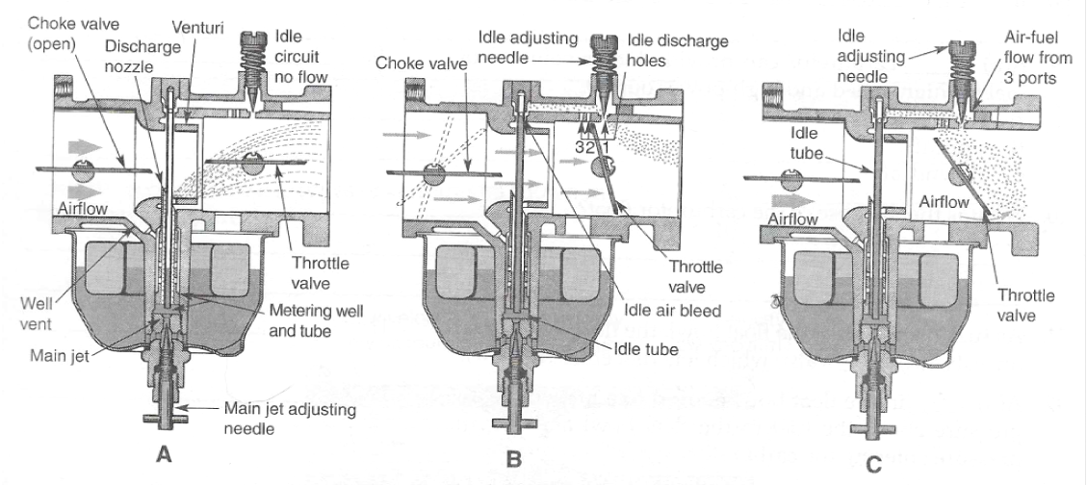
- Which of the drawings above shows the throttle valve in the idling position?

- Which of the drawings above shows the throttle valve in the full throttle position?

- Which of the drawings above shows the throttle valve in the part throttle position?

- Explain the function of the Governor.

Label the parts of the Natural Draft Carburetor:

